1. **what exactly is deep learning**?
   1. **‘Deep Learning’ means** using a **neural network** with **several layers of nodes** between input and output
2. **why is it generally better** than other methods on image, speech and certain other types of data?
   1. **The series of layers between input & output do feature identification and processing in a series of stages, just as our brains seem to.**
3. 图片包含 屏幕截图

   描述已自动生成
4. Hidden layer units become   
   self-organised feature detectors
5. What does this unit detect(检测)?
   1. it will send strong signal for a horizontal line in the top row, ignoring everywhere else
   2. 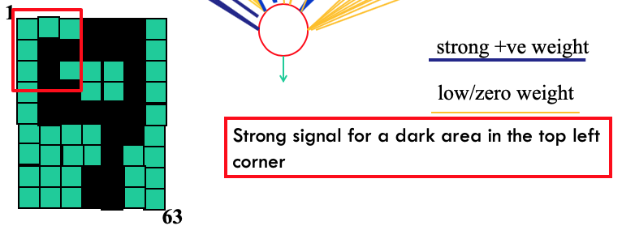
6. 图片包含 屏幕截图

   描述已自动生成
   1. **an auto-encoder is trained, with an absolutely standard weight-adjustment algorithm (backprop) to reproduce the input**
   2. By making this happen with (many) fewer units than the inputs, this forces the ‘hidden layer’ units to become good feature detectors
7. 图片包含 屏幕截图

   描述已自动生成
8. 图片包含 屏幕截图

   描述已自动生成
9. 图片包含 屏幕截图

   描述已自动生成